Paper Wallet
# Source: AI Source: Provided by: [Data Path: Persons Table -> ID Column: 1, Name_En Column: Motasem Essam] -> From: [ChatGPT] on [1/21/2026]
A Paper Wallet is a type of cold crypto wallet that involves printing or writing down your public and private keys (or QR codes) on a physical sheet of paper. It is a form of offline storage and is one of the most basic and secure (if handled properly) ways to store cryptocurrency keys.

📄 Key Characteristics of Paper Wallets:
# Source: AI Source: Provided by: [Data Path: Persons Table -> ID Column: 1, Name_En Column: Motasem Essam] -> From: [ChatGPT] on [1/21/2026]
- Fully Offline
  - No software or hardware required.
  - Immune to online hacking, malware, and viruses.
- Non-Custodial
  - You have full control over your keys and access.
  - No third party is involved.
- Key Pair or QR Code Format
  - Often includes:
  - A public address for receiving crypto
  - A private key for accessing/spending the crypto
  - Both in text and QR code format for scanning convenience
- One-Time Use Recommended
  - Paper wallets are best suited for long-term storage, not daily use.
  - Reusing them for multiple transactions increases security risks.

🧾 How to Generate a Paper Wallet:
# Source: AI Source: Provided by: [Data Path: Persons Table -> ID Column: 1, Name_En Column: Motasem Essam] -> From: [ChatGPT] on [1/21/2026]
- Use an offline wallet generator (e.g., bitaddress.org, walletgenerator.net).
- Download the generator and run it offline (never generate online).
- Move your mouse or type random characters to generate entropy.
- Print or write down the generated keys/QR codes.
- Store the paper securely (safe, vault, or fireproof box).

✅ Advantages:
# Source: AI Source: Provided by: [Data Path: Persons Table -> ID Column: 1, Name_En Column: Motasem Essam] -> From: [ChatGPT] on [1/21/2026]
- Air-gapped: Completely offline and safe from online attacks
- No device needed to store keys
- Free to create and maintain
- Ideal for cold storage of long-term holdings

⚠️ Disadvantages:
# Source: AI Source: Provided by: [Data Path: Persons Table -> ID Column: 1, Name_En Column: Motasem Essam] -> From: [ChatGPT] on [1/21/2026]
- Easily damaged, lost, or stolen (paper is fragile)
- No password protection — if someone finds it, they can access your funds
- Difficult to use for spending or partial withdrawals
- Requires extreme caution during generation, storage, and usage

🧠 Best Use Cases:
# Source: AI Source: Provided by: [Data Path: Persons Table -> ID Column: 1, Name_En Column: Motasem Essam] -> From: [ChatGPT] on [1/21/2026]
- Long-term crypto storage
- Creating gift wallets
- Holding Bitcoin, Ethereum, or other coins securely without frequent access
- Use in crypto time capsules or physical backup kits

🆚 Comparison with Other Wallet Types:
# Source: AI Source: Provided by: [Data Path: Persons Table -> ID Column: 1, Name_En Column: Motasem Essam] -> From: [ChatGPT] on [1/21/2026]
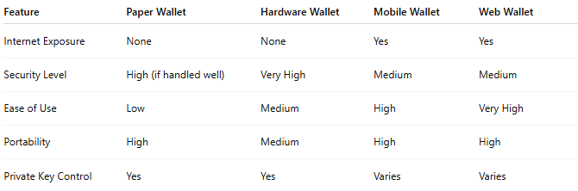

Feature | Paper Wallet | Hardware Wallet | Mobile Wallet | Web Wallet
Internet Exposure | None | None | Yes | Yes
Security Level | High (if handled well) | Very High | Medium | Medium
Ease of Use | Low | Medium | High | Very High
Portability | High | Medium | High | High
Private Key Control | Yes | Yes | Varies | Varies

🔐 Security Tips for Paper Wallets:
# Source: AI Source: Provided by: [Data Path: Persons Table -> ID Column: 1, Name_En Column: Motasem Essam] -> From: [ChatGPT] on [1/21/2026]
- Generate completely offline
- Use a secure printer (avoid shared/public printers)
- Never save digital copies (no ScreenShot, no cloud storage)
- Store in a safe, tamper-proof, fire/water-resistant location
- Consider laminating or engraving on metal for durability

